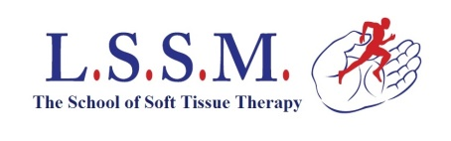 | 28 Station Parade,  Willesden Green,  London NW2 4NX | Tel: 020 8452 8855  Fax: 020 8452 4524  Email: admin@lssm.com

Terms and Conditions for Monthly Payments

Once you begin the course you are liable for the full fee whether you complete the course or not. If you stop your monthly payments for any reason you must make a payment for the full remainder of any outstanding fee.

Monthly payments must be made through a standing order with your bank or Building Society; we do not take monthly payments by cash or cheque.
(You must complete both parts of the standing order form below)

I accept the above conditions:

Sign | Date

……………………………………………………………………………………….

STANDING ORDER FORM

Name | Course code
Bank: please use this reference code.

Bank Name |  |  |  |  |  |  |  |  |  |  | Bank Address & Postcode
Branch |  |  |  |  |  |  |  |  |  |  | Bank Address & Postcode
Sort Code |  |  |  |  |  |  |  |  |  |  | Bank Address & Postcode
Name of account |  |  |  |  |  |  |  |  |  |  | Bank Address & Postcode
Account number |  |  |  |  |  |  |  |  |  |  | Bank Address & Postcode

I instruct you to make | 2 | Monthly payments of | £250 | commencing
1st …………………2018 (month following the start of your course)

To
London School of Sports Massage;
Sort code: 30-99-64, Account no: 01282752

Sign | Date

